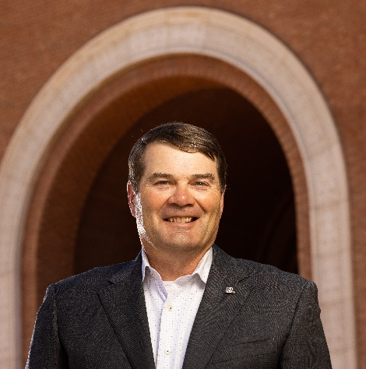
Office of the Dean
Dr. Gary Packard, Jr. is the founding dean of the College of Applied Science and Technology (CAST) at the University of Arizona, Sierra Vista. In this role, Gary leads the university's fastest-growing college in the development and implementation of a broad strategic vision for growing the college's programs at all levels.
"The College of Applied Science and Technology is an exciting, fast-growing, and innovative college that lives up to its commitment to educating students to be future-focused and career ready. Our faculty and staff are dedicated to excellence in education, opening doors for well-paying and impactful careers for diverse post-traditional students. This team's commitment to offering attainable academic programming without lowering the bar was why I wanted to be a part of this team. Our team is transforming lives with an integrated curriculum in our one-of-a-kind virtual learning environment. We truly are working at the convergence of human and machine teaming to prepare today's learners for the realities of the 21st century. I hope you will check us out and consider joining our exciting journey."
— Dr. Gary Packard, Jr.
Future-Focused – Career-Ready
A retired brigadier general with a career spanning over 37 years as an Air Force officer, Gary served as a pilot, instructor pilot, evaluator, deployed director of staff, operations officer, and commander. He finished his flying career with over 3,900 hours in military aircraft. In addition, Gary also served nearly 20 years at the United States Air Force Academy as an instructor, permanent professor, department head, and vice dean. Gary served at the Pentagon as a writer on the influential 2010 Department of Defense study that led to the repeal of Don't Ask, Don't Tell.
Gary earned a doctorate in Developmental Psychology from the University of North Carolina at Chapel Hill, focusing on social network influences on leadership and professional military development for cadets at the U.S. Air Force Academy. In addition, he has a master's degree in Counseling from Michigan State University, a master's degree in Aeronautical Science from Embry Riddle Aeronautical University, and a bachelor of science degree in Behavioral Science from the United States Air Force Academy.

